Lenovo G40-30 / NM-A311 Rev 1.0 ki schematic
Is board ki kuch important information:
- CPU: Intel BayTrail-M (BGA1170)
- EC/SIO: ITE IT8586E
- BIOS: 8MB SPI Flash
- DDR3L Memory
- BayTrail SoC (PCH CPU ke andar hi integrated hai, alag PCH IC nahi hai.) Lenovo G40 30 NM-A311 REV 1.0 Schematics.pdf

Is schematic se hum kya kya seekhenge
Main is board se complete repair course jaisa sequence nikal sakta hoon:
- ✅ Charger Section
- ✅ 3V/5V ALW Generation
- ✅ RTC Circuit
- ✅ SIO Inputs
- ✅ SIO Outputs
- ✅ BIOS Communication
- ✅ Power Button Sequence
- ✅ SUSCLK
- ✅ PM_RSMRST#
- ✅ SLP_S5#, SLP_S3#
- ✅ CPU Power Rails
- ✅ Display Sequence

Repair Engineer Rule
Agar aap dead motherboard troubleshoot kar rahe hain, to Power Button dabane se pehle har board par lagbhag ye hi check karte hain:
- ✅ 19V
- ✅ Charger IC
- ✅ +3VALW / +5VALW
- ✅ RTC_VCC
- ✅ 32.768 kHz
- ✅ EC/SIO VCC
- ✅ EC_RST#
- ✅ BIOS Communication
- ✅ ACIN#
- ✅ LID_SW#
- ✅ Thermal / Protection Signals
- ✅ SIO Ready
Iske baad hi Power Button ka signal process hota hai.
SIO Basic Requirement (Before Power Button)
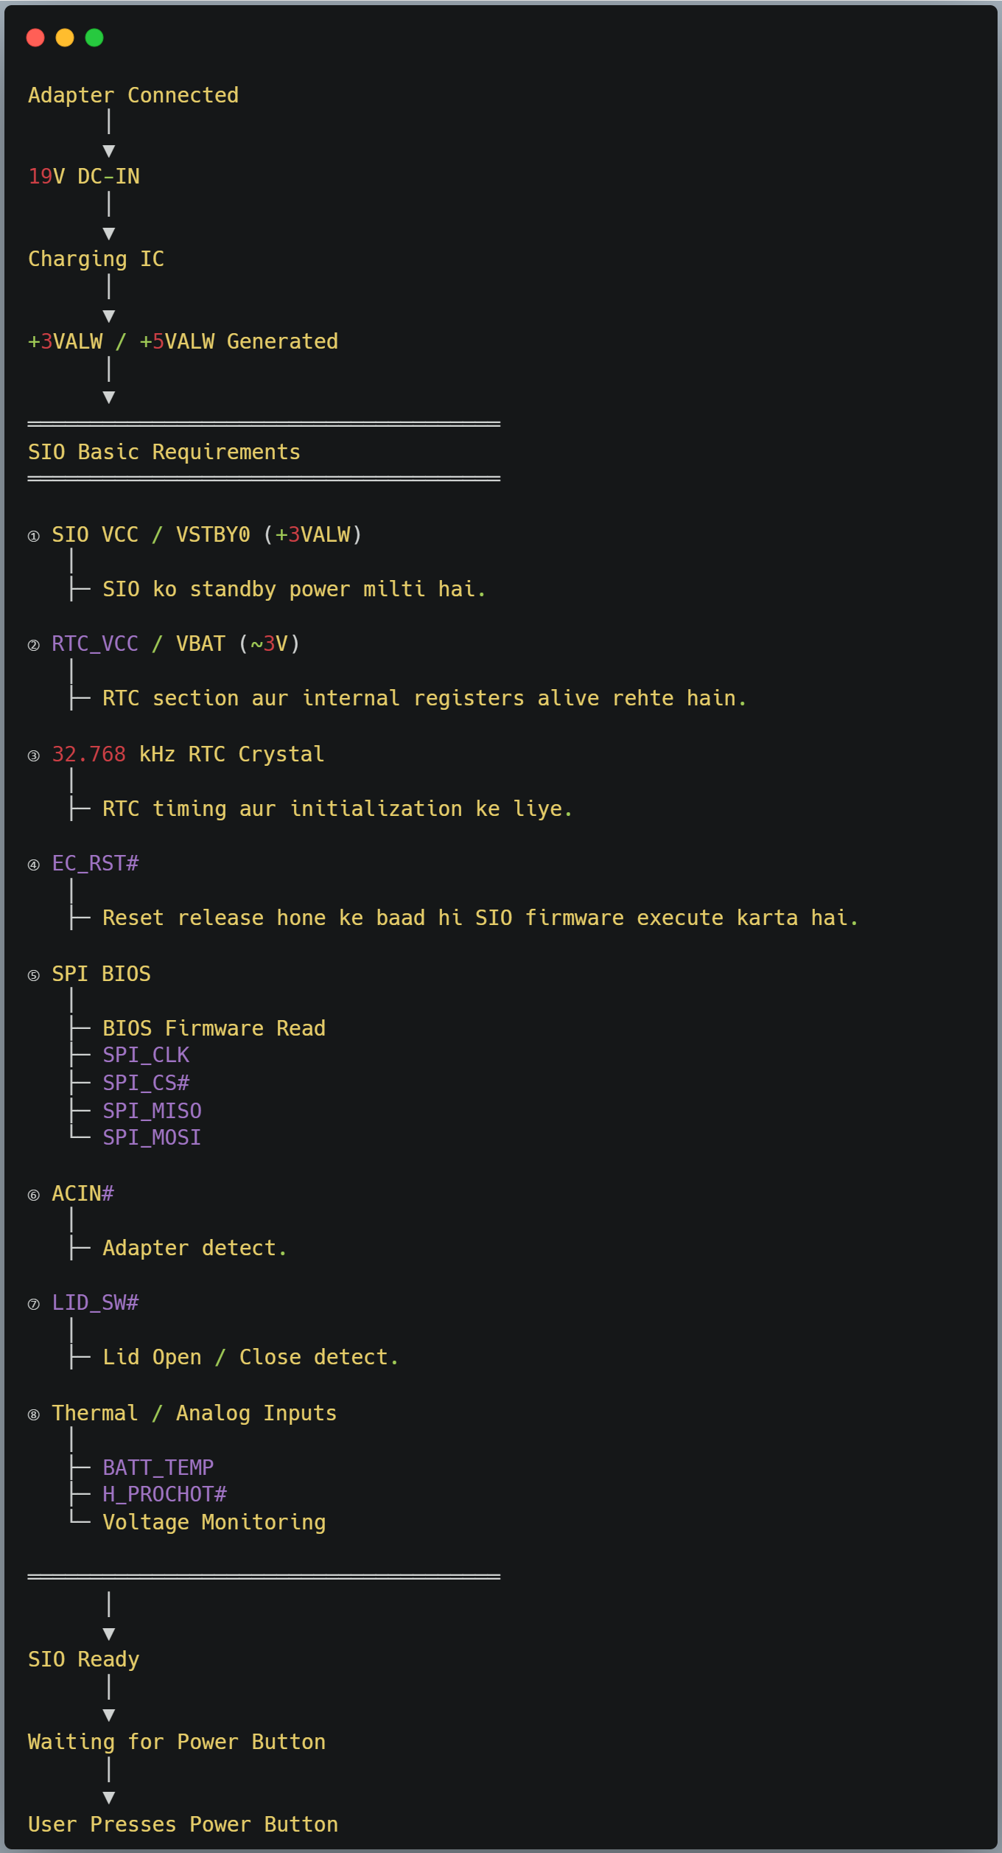

SIO ki Minimum Basic Inputs
Signal | Required | Function
✅ VCC / VSTBY0 (+3VALW) | Yes | SIO Power
✅ RTC_VCC / VBAT | Yes | RTC Power
✅ 32.768 kHz Crystal | Yes (board dependent but recommended) | RTC Clock
✅ EC_RST# | Yes | SIO Start
✅ SPI BIOS | Yes | Firmware Execute
✅ ACIN# | Yes | Adapter Detect
✅ LID_SW# | Optional for boot, but important | Lid Detect
✅ Thermal Inputs | Protection | Temperature Monitoring

Agar SIO ki ye 8 basic requirements complete nahi hongi, to:
• ❌ Power Button ka response nahi milega.
• ❌ PBTN_OUT# generate nahi hoga.
• ❌ Aage ka power sequence (SUSCLK, PM_SLP_S5#, PM_SLP_S3#, etc.) start nahi hoga.

Power Button Press ke Baad Complete Sequence

User Presses Power Button
│
▼
1. ON/OFF Signal → SIO
│
▼
2. SIO Debounce (10~50ms)
│
▼
3. SIO checks:
├─ ACIN#
├─ RTC OK
├─ BIOS Running
├─ Thermal OK
├─ Lid Status
└─ No Protection
│
▼
4. PBTN_OUT#
│
▼
5. SoC detects Power Button
│
▼
6. SUSCLK Start
│
▼
7. PM_RSMRST# Release
│
▼
8. PM_SLP_S5# HIGH
│
▼
9. SYSON / EC_ON
│
▼
10. +3VS / +5VS
│
▼
11. PM_SLP_S3# HIGH
│
▼
12. Main Power Rails ON
(+1.8V, +1.05V,
VCCSA, VCCIO,
CPU Core ...)
│
▼
13. PLT_RST#
│
▼
14. BIOS Read by SoC
│
▼
15. POST
│
▼
16. Display

Repair Rule
Signal | Kaun Generate Karta Hai? | Kahan Measure Karte Hain?
PBTN_OUT# | SIO (EC) | SIO output pin
SUSCLK | SoC (internal PM logic) | SoC output pin
PM_RSMRST# | SoC | SoC output pin
PM_SLP_S5# | SoC | SoC output pin
PM_SLP_S3# | SoC | SoC output pin
PLT_RST# | SoC | SoC output pin

